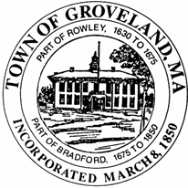 | Groveland Housing Authority  10 River Pines Road  Groveland, Massachusetts 01834  978-374-0370 Phone 978-374-7621 Fax
GROVELAND HOUSING AUTHORITY
2021-2026 CAPITAL FUNDING PLAN
PUBLIC NOTICE
IMPORTANT NOTICE ANNOUNCING THE AVAILABILITY OF
THE GROVELAND HOUSING AUTHORITY CAPITAL FUNDING PLAN 2021-2026

The Groveland Housing Authority will be submitting to the U.S. Department of Housing and Urban Development (HUD) their Capital Funding for year 2021-2026.

A public hearing will be held for the purpose of receiving suggestions, proposals and ideas from interested residents and citizens concerning the proposed use of the Capital Fund.

The public hearing will take place Wednesday, October 12, 2022 at 10:00A.M. in the Groveland Housing Authority, Community Room located at 10 River Pine Road, Groveland, MA.

Comments from the public are welcome during the Public Hearing or may be submitted in writing up until October 11, 2022 and address to Clara Ruiz Vargas, Haverhill Housing Authority, 25C Washington Square, Haverhill, MA 01831 or email to clara@haverhillhousing.com.

Persons needing additional accommodation should contact Robin Cotreau at telephone number 978-372-6761 or email: robin@haverhillhousing.com

The Groveland Housing Authority is an equal opportunity

