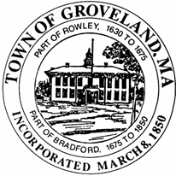 | Groveland Housing Authority  10 River Pines Road  Groveland, Massachusetts 01834  978-374-0370 Phone 978-374-7621 Fax
GROVELAND HOUSING AUTHORITY
2021-2026 CAPITAL FUNDING PLAN

2021-Common Area Carpeting
Replace carpeting in common halls in apartment buildings and the community room. $111,430.00

2022-Keyless Lock Systems
Replace all entry doors, and install electronic locks for common entry doors. $135,880.00

2023-Remove all pull cords/Closet door replacement
Remove and cover all non-function older pull cord. $25,500.00
Closet Door Replacement $75,000.00
Operation $11,143.00

2024- Repoint chimney/Bathroom Renovation
Caulk repair/replace cracked bricks, patch hairline crack with sealant, cap repairment $50,000.00
Bathroom Renovation $85,1143.00
Operation $11,143.00

2025- Site lighting and Security Camera
Install site lighting and security cameras at buildings and ground $15,000.00
Water Filtration Project $20,787.00
Kitchen Renovation $109,643.00

2026-Paving
Paving and repair of roadway, stripping and numbering parking spaces sitework $100,000.00
Operation $11,430.00

